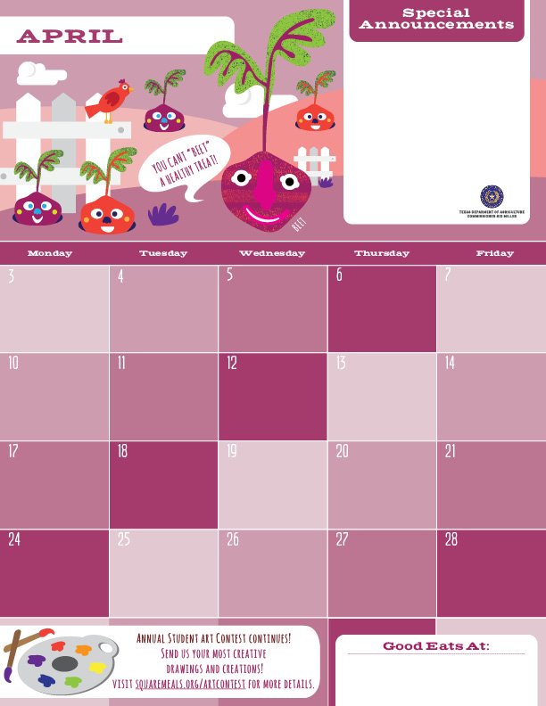

**Hop into Spring!!! Go outdoors and enjoy the warmer weather and don’t forget to eat your vegetables and fruits every day.**

**Mini French Toast**

**Gogurt**

**Craisins**

**Milk**

**Yogurt Parfait Cups**

**Granola**

**Apple Slices**

**Milk**

**Strawberry Bagels**

**Cheese Sticks**

**Bananas**

**Milk**

**Muffins**

**Gogurt**

**Oranges**

**Milk**

**Breakfast Break Bags**

**Milk**

**NO SCHOOL**

**HOLIDAY**

**NO SCHOOL**

**STAFF DEVELOPMENT**

**Cini Minis**

**Yogurt Parfait Cups**

**Fruit Choice**

**Milk**

**Chocolate Waffles**

**Gogurt**

**Grapes**

**Milk**

**Cereal Cups**

**Cheese Sticks**

**Oranges**

**Milk**

**Chocolate Oatmeal Bars**

**Cheese Sticks**

**Grapes**

**Milk**

**Mini French Toast**

**Cheese Sticks**

**Craisins**

**Milk**

**Pancakes**

**Yogurt Parfait Cups**

**Bananas**

**Milk**

**Nutri-grain Bars**

**Gogurt**

**Fruit Choice**

**Milk**

**Cereal Cups**

**Cheese Sticks**

**Oranges**

**Milk**

**Blueberry Waffles**

**Gogurt**

**Apple Slices**

**Milk**

**Donuts**

**Yogurt Parfait Cups**

**Oranges**

**Milk**

**Breakfast Break Bags**

**Milk**

**NO SCHOOL**

**HOLIDAY**

**Banana Loaf**

**Gogurt**

**Fruit Choice**

**Milk**

**The Pegasus School of Liberal Arts and Sciences!**

**(The Amazing Lower School)**

