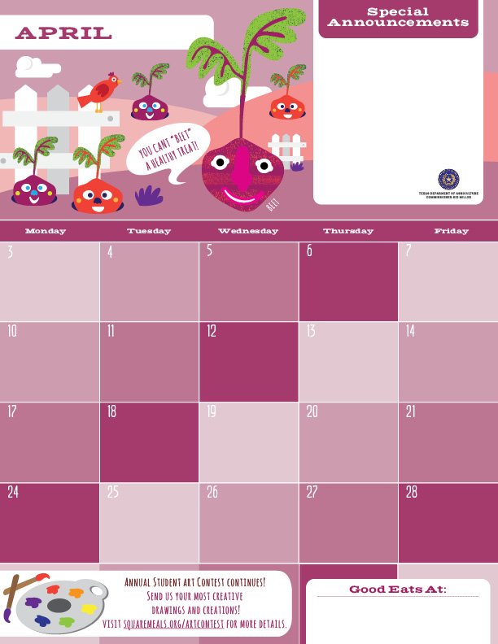

**Hop into Spring!!! Go outdoors and enjoy the warmer weather and don’t forget to eat your vegetables and fruits every day.**

**Chili Cheese Hot Dogs**

**Broccoli**

**Apple Slices**

**Baked Cheetos**

**Milk**

**Ham and Cheese Hot Pockets**

**Celery Sticks**

**Grapes**

**Goldfish Crackers**

**Milk**

**Chicken Biscuits**

**Jicama**

**Oranges**

**Animal Crackers**

**Milk**

**Beef and Cheese Taco Sticks**

**Jicama**

**Bananas**

**Graham Crackers**

**Milk**

**Beef Ravioli**

**Baby Carrots**

**Oranges**

**Zoo Crackers**

**Milk**

**NO SCHOOL**

**HOLIDAY**

**NO SCHOOL**

**STAFF DEVELOPMENT**

**Pepperoni Pizza Sub**

**Celery Sticks**

**Apple Slices**

**Baked Cheetos**

**Milk**

**Grilled Cheese Sandwiches**

**Broccoli**

**Grapes**

**Animal Crackers**

**Milk**

**Hot Turkey Bologna w/ Cheese Sub**

**Baby Carrots**

**Oranges**

**Sun Chips**

**Milk**

**Pizza**

**Broccoli**

**Apple Slices**

**Baked Cheetos**

**Milk**

**Mini Cheeseburgers**

**Broccoli**

**Apple Slices**

**Baked Cheetos**

**Milk**

**Ham and Cheese Hot Pockets**

**Celery Sticks**

**Grapes**

**Goldfish Crackers**

**Milk**

**Bean and Cheese Burritos**

**Jicama**

**Oranges**

**Chocolate Graham Crackers, Milk**

**Milk**

**Mac and Cheese Plate**

**Jicama**

**Bananas**

**Zoo Crackers**

**Milk**

**Hot Turkey Bologna w/ Cheese Sub**

**Baby Carrots**

**Fruit Cups**

**Sun Chips**

**Milk**

**Pepperoni Pizza Sub**

**Celery Sticks**

**Grapes**

**Goldfish Crackers**

**Milk**

**Chicken and Rice Burritos**

**Jicama**

**Bananas**

**Animal Crakers**

**Milk**

**Spaghetti and Meatballs**

**Baby Carrots**

**Oranges**

**Zoo Crackers**

**Milk**

**NO SCHOOL  
HOLIDAY**

**The Pegasus School of Liberal Arts and Sciences!**

**(The Amazing Lower School)**

