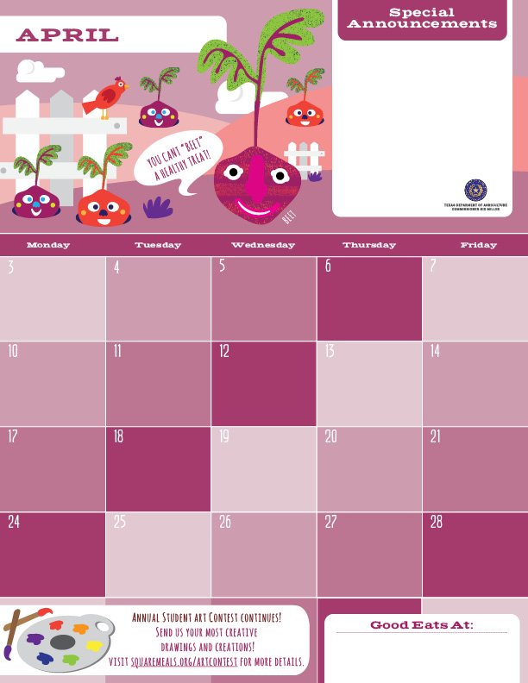

**Hop into Spring!!! Go outdoors and enjoy the warmer weather and don’t forget to eat your vegetables and fruits every day.**

**Chocolate Chip Granola Bars**

**Juice Box**

**Cinnamon Bun Crackers**

**Gogurt**

**Strawberry Pop Tarts**

**Juice Box**

**Conchas**

**Cheese Sticks**

**Cinnamon Churro Sticks**

**Fruit Choice**

**NO SCHOOL**

**HOLIDAY**

**NO SCHOOL**

**STAFF DEVELOPMENT**

**Mini Fudge Strip Cookies**

**Juice Box**

**Applesauce**

**Teddy Graham Crackers**

**Banana Loaf**

**Gogurt**

**Chocolate Pop Tarts**

**Juice Box**

**Chocolate Chip Cookies**

**Juice Box**

**Honey Bunny Crackers**

**Cheese Sticks**

**Baked Fantastix Chips**

**Juice Box**

**Muffins**

**Gogurt**

**Pretzels**

**Sun butter Cups**

**Soy Butter and Jelly Sandwiches**

**Cocoa Krispies Chocolate Granola Bars**

**Juice Box**

**Chex Mix Bags**

**Fruit Choice**

**NO SCHOOL**

**HOLIDAY**

**The Pegasus School of Liberal Arts and Sciences!**

